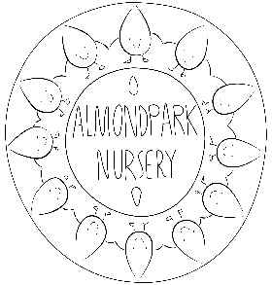
Please return both completed forms electronically or via post to:
Post: HR at Almond Park Nursery
Macbeth Moir Road, Musselburgh, EH21 8JE
Email: info@almondparknursery.co.uk
Post Applied for: Ref:

Recruitment Enquiries: 0131 665 4136
NOTES:
Please complete each section as appropriate; ensuring that they are in chronological order.
Please do not add a separate CV as this will not be considered.
Canvassing, directly or indirectly, will disqualify your application.
Employment History (Present or most recent Employment)
Dates:
From: To:
Name and address of employer:
Position Held:
Current Salary: | Notice Period:
Description of Main Duties and responsibilities:
Please give your reason for leaving:

Previous Employment (Please start with most recent and include any period not in paid employment)
Dates (MM/YY)  From To |  | Name and Address of Employer | Position Held, Description of Duties and Responsibilities | Reason for Leaving

Qualifications
Name of Establishment | Dates (MM/YY)  From To |  | Qualification Gained | Method of Study (i.e. part-time, full time) | Date of Award

Membership of professional bodies – membership of SSSC should also include membership number
Class of Membership | Name of Professional Body | Qualification/Award | Date of Award

Additional Information

Please include details of any skills, aptitudes, or personal qualities which you feel are relevant and explain how you might use them in this post. Additional information may be added on a separate sheet.

